**Database-Style Data Frame Joins**

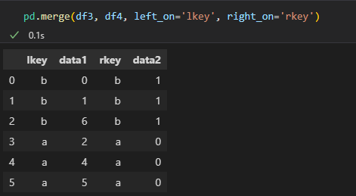

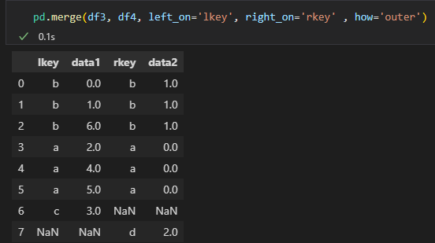

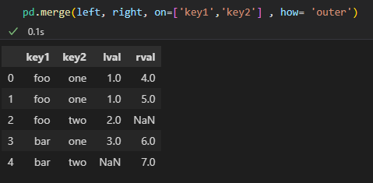

**Merging on Index**

**Concatenating Along an Axis**

**-Along Col**

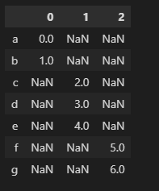

**-With Keys**

**Combining Data with Overlap**

**Reshaping**

